EVENT REPORT
BHARAT PITCHATHON 3.0
Unearthing Startups from Bharat
DATE  6 July 2024 | TIME  10:00 a.m. – 5:00 p.m.
VENUE  TBI Conference Hall, N Block, 2nd Floor | ORGANISATION  Vignan TBI, with support from the Office of Dean PCF

1. Introduction
Bharat Pitchathon 3.0 was organised at Vignan Technology Business Incubator (Vignan TBI) on 6 July 2024. Presented by Headstart, the programme was conducted under the theme “Unearthing Startups from Bharat” and provided a platform for startup founders and innovators to present their ideas, explain their business models and receive feedback from experienced members of the startup ecosystem. The event was held from 10:00 a.m. to 5:00 p.m. at the TBI Conference Hall, N Block, second floor.
The event brought together startup ecosystem representatives, mentors, founders and invited guests. The poster identifies Eashita Maheshwary, Lead Community – Platforms, Razorpay; Zaran Bhagwagar, AVP, XelpmoC; Varun AG Reddy, Managing Partner, AGR Corporate Consultants and CEO, Indie Cocktail Co; and Ashwathy Venugopal, Co-Founder, Avasarshala and Headstart AP Lead. Faculty representatives from the Footwear Design and Development Institute (FDDI), Hyderabad, were also listed as special invitees.

2. Objectives of the Event
- Provide a platform for early-stage startups and student innovators to present business ideas and technology-based solutions.
- Enable founders to receive constructive feedback from mentors, industry professionals and startup ecosystem representatives.
- Encourage entrepreneurial thinking, business-model development and refinement of startup concepts.
- Promote connections between founders, mentors, investors and institutions supporting entrepreneurship.
- Increase awareness of startup opportunities and strengthen the regional startup ecosystem through community engagement.
- Encourage participants to assess market needs, customer value and possible growth pathways for their ventures.

3. Programme Highlights
Startup pitching and idea presentation. Startup teams presented business ideas and technology solutions, explaining the problems they aim to solve, the value offered by their solutions and the potential for future development.
Mentor and ecosystem interaction. Startup community leaders and industry representatives provided varied perspectives on entrepreneurship, product development and business growth.
Feedback and idea refinement. Pitch-based discussions gave founders a setting to reflect on their business propositions, identify areas requiring further validation and consider ways to improve the clarity of their presentations.
Institutional engagement. The event was organised by Vignan TBI with support from the Office of the Dean, PCF, demonstrating coordination between the incubator and the university to support entrepreneurial activity.
FDDI participation. Faculty representatives from FDDI, Hyderabad, were invited to the programme. Their participation created scope for interaction on innovation, skills and potential institutional collaboration, as described in the supplied event summary.

4. Guests and Special Invitees
- Eashita Maheshwary — Lead Community, Platforms, Razorpay
- Zaran Bhagwagar — AVP, XelpmoC
- Varun AG Reddy — Managing Partner, AGR Corporate Consultants; CEO, Indie Cocktail Co
- Ashwathy Venugopal — Co-Founder, Avasarshala; Headstart AP Lead
- Faculty representatives from the Footwear Design and Development Institute (FDDI), Hyderabad

5. Outcomes and Impact
- Startup visibility: The pitchathon gave participating founders a forum to present their ideas to an audience connected with entrepreneurship and startup support.
- Pitching practice: Participants practised explaining their venture, communicating the problem they are addressing and presenting their proposed solution in a structured format.
- Feedback-led improvement: Interaction with experienced ecosystem representatives created scope for founders to identify gaps, refine their value proposition and improve future pitches.
- Entrepreneurial confidence: Presenting ideas in a formal pitch setting can help founders strengthen communication, respond to questions and build confidence in discussing their ventures.
- Ecosystem networking: The event brought together startup teams, community leaders, mentors and institutional stakeholders, supporting connections that may be useful for future guidance and collaboration.
- University–incubator coordination: The programme highlighted Vignan TBI’s role in creating opportunities for startup engagement in coordination with the Office of the Dean, PCF.
- Institutional outreach: FDDI faculty participation created an opportunity to explore future dialogue on innovation, skill development and possible collaboration between institutions.
- Regional entrepreneurship promotion: By providing a dedicated platform for startup ideas, the event contributed to awareness of entrepreneurship and the support available through the wider startup ecosystem.
- Follow-on development: Feedback from pitching and networking can help teams identify next steps such as validating customer needs, strengthening business models, improving presentations and pursuing suitable mentoring or incubation support.
Overall Outcome: Bharat Pitchathon 3.0 provided a structured platform for founders to showcase ideas, practise pitching and engage with the startup ecosystem. It reinforced Vignan TBI’s role in enabling entrepreneurial learning, increasing startup visibility and facilitating connections between innovators, mentors and institutional partners.
- Founder readiness: The pitching environment encouraged founders to communicate their business problem, solution and intended users more clearly—skills that are useful when approaching customers, mentors and potential partners.
- Problem–solution clarity: Presentations created an opportunity for teams to examine whether their proposed solutions address a clear need and to consider which parts of their ideas require additional validation.
- Peer learning: By sharing a common platform, participants could learn from the variety of startup ideas and presentation approaches, broadening their understanding of entrepreneurship across different sectors.
- Mentorship pathways: The event strengthened the visibility of Vignan TBI as a point of connection for founders seeking guidance, incubation-related support and continued engagement with the startup ecosystem.
- Relationship building: Direct interaction among founders, ecosystem representatives and institutional stakeholders helped create a foundation for follow-up conversations, knowledge sharing and possible future collaboration.
- Innovation culture: The programme supported a culture in which ideas can be presented, questioned and improved through discussion, encouraging participants to treat feedback as part of the startup development process.

6. Conclusion
Bharat Pitchathon 3.0, held on 6 July 2024 at Vignan TBI, was an entrepreneurship-focused programme that brought startup pitching, ecosystem interaction and institutional engagement together in one venue. Through the presentation of business ideas and interaction with invited startup representatives, the event supported entrepreneurial confidence and offered founders an opportunity to reflect on the next stages of their ventures. Organised by Vignan TBI with support from the Office of the Dean, PCF, the programme contributed to the incubator’s broader objective of fostering innovation and supporting startup growth.

7. Event Photographs
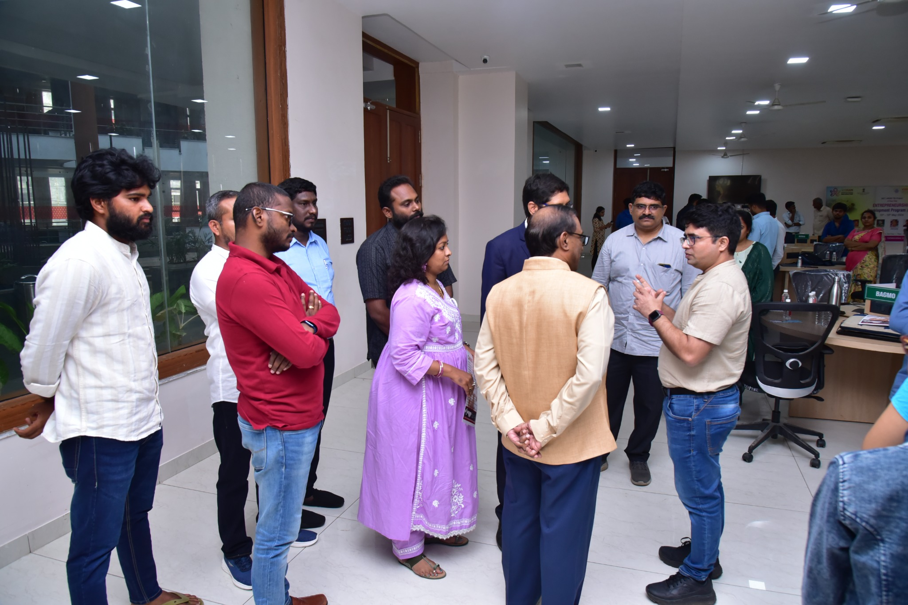
Interaction and discussion among participants during Bharat Pitchathon 3.0.
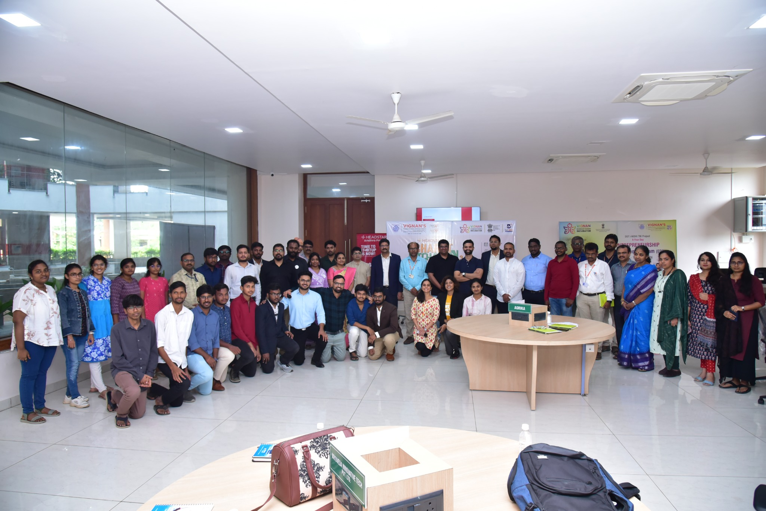
Group photograph of participants and startup ecosystem representatives at Vignan TBI.

8. Event Poster
Event poster for Bharat Pitchathon 3.0, held on 6 July 2024.
